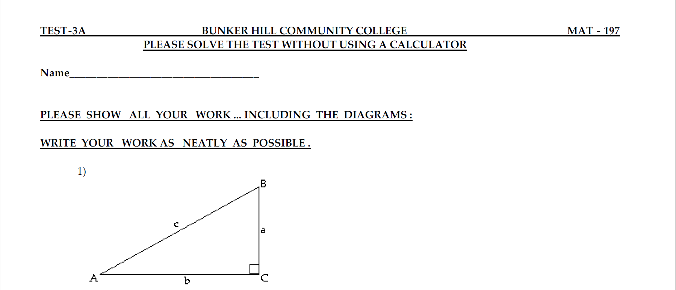
Let $c=13cm, b=12cm,, find:$
First let us calculate a, which is given by
$$c^{2}=a^{2}+b^{2}→ a=\sqrt{c^{2}-b^{2}}=a=\sqrt{{13}^{2}-{12}^{2}}=5$$
- $\cos{A}$
$$Cos A=\frac{b}{c}=\frac{12}{13}$$

- $\sin{B}$
$$\sin{B}=\frac{b}{c}=\frac{12}{13}$$

- $\tan{A}$
$$\tan{A}=\frac{a}{b}=\frac{5}{12}$$

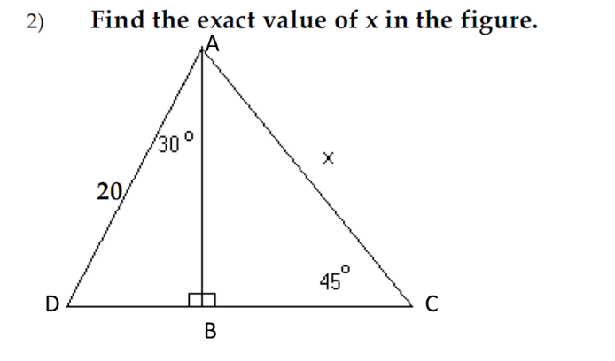

In triangle DBA
$$\cos{{30}^{0}}=\frac{AB}{AD}→\frac{\sqrt{3}}{2}=\frac{AB}{20}→AB=10\sqrt{3}$$

In triangle ABC
$$∠BAC+∠ABC+∠BCA={180}^{0}→∠BAC={45}^{0}$$
$$→∠BAC=∠BCA→AB=AC$$

From Pythagoras theorem
$$AB^{2}+BC^{2}=AC^{2}$$
$$→{\left(10\sqrt{3}\right)}^{2}+{\left(10\sqrt{3}\right)}^{2}=x^{2}$$
$$→x=10\sqrt{6}$$

The terminal side is in the second quadrant (angles from 90° to 180°), our reference angle is 180° minus our given angle.
$$→{510}^{0}= 150+360→{150}^{0}$$
$Reference angle ={30}^{0}$, Second quadrant

Exact value of $\tan{{510}^{0}}=-\tan{{30}^{0}}= -\frac{1}{\sqrt{3}}$

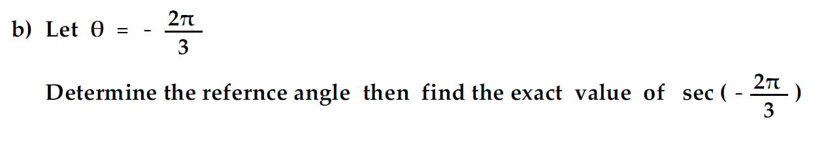
The terminal side is in the third quadrant (angles from 180° to 270°), our reference angle is our given angle minus 180°
$$→ -\frac{2π}{3}=\frac{π}{3} , Third quadrant$$
$\sec\left(-\frac{2π}{3}\right)= -$2

Yes, the point lies on a unit circle, because
Because for unit circle $x^{2}+y^{2}=1$
Putting values of x,y , we get
$${\left(\frac{1}{\sqrt{5}}\right)}^{2}+{\left(-\frac{2}{\sqrt{5}}\right)}^{2}=1$$
Hence a unit circle

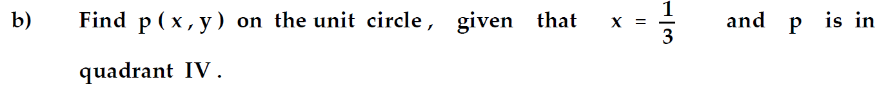
For unit circle $x^{2}+y^{2}=1$
$${\left(\frac{1}{3}\right)}^{2}+y^{2}=1→y^{2}=1-{\left(\frac{1}{3}\right)}^{2}$$
$$y=\sqrt{\frac{8}{9}}=-\frac{2\sqrt{2}}{3}, becuase p is in IV quadrant$$
$$P\left(x,y\right)=P\left(\frac{1}{3},-\frac{2\sqrt{2}}{3}\right)$$

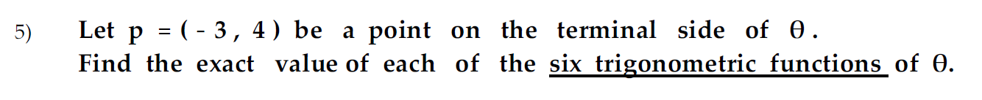
Point P(-3,4) , lies in second quadrant
Hence
$$\sin{θ}=\frac{4}{\sqrt{{\left(-3\right)}^{2}+4^{2}}}=\frac{4}{5}$$
$$\cos{θ}= -\frac{3}{\sqrt{{\left(-3\right)}^{2}+4^{2}}}= -\frac{3}{5}$$
$$\tan{θ}=\frac{\sin{θ}}{\cos{θ }}= -\frac{4}{5}$$
$$\csc{θ}=\frac{1}{\sin{θ}}=\frac{5}{4}$$
$$\sec{θ}=\frac{1}{\cos{θ}}= -\frac{5}{3}$$
$$\cot{θ}=\frac{1}{\tan{θ}}= -\frac{5}{4}$$

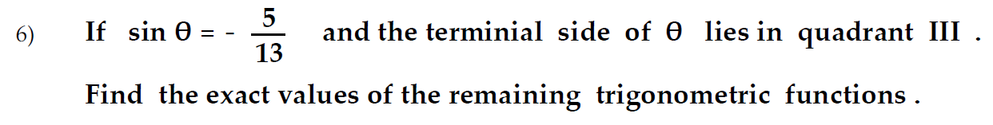
$$\sin{θ}= -\frac{5}{13}=\frac{P}{H}$$
Base of a triangle with angle $θ$ can be calculated as $B=\sqrt{{13}^{2}-5^{2}}=12$

Since $θ$ lies in III quadrant
$$\sin{θ}= -\frac{5}{13}$$
$$\cos{θ}=\frac{B}{H}=-\frac{12}{13}$$
$$\tan{θ}=\frac{\sin{θ}}{\cos{θ}}=\frac{5}{12}$$
$$\csc{θ}=\frac{1}{\sin{θ}}=-\frac{13}{5}$$
$$\sec{θ}=\frac{1}{\cos{θ}}= -\frac{13}{12}$$
$$\cot{θ}=\frac{1}{\tan{θ}}= \frac{12}{5}$$

$$\tan{θ}=\sqrt{3}=\frac{P}{B}$$
Hypotenuse of the triangle with angle $θ$ can be calculated as
$$H=\sqrt{P^{2}+B^{2}}=2$$

Since $θ$ lies in III quadrant
$$\sin{θ}=\frac{P}{H}= -\frac{\sqrt{3}}{2}$$
$$\cos{θ}=\frac{B}{H}=-\frac{1}{2}$$
$$\tan{θ}=\sqrt{3}$$
$$\csc{θ}=\frac{1}{\sin{θ}}=-\frac{2}{\sqrt{3} }$$
$$\sec{θ}=\frac{1}{\cos{θ}}= -2$$
$$\cot{θ}=\frac{1}{\tan{θ}}= \frac{1}{\sqrt{3}}$$

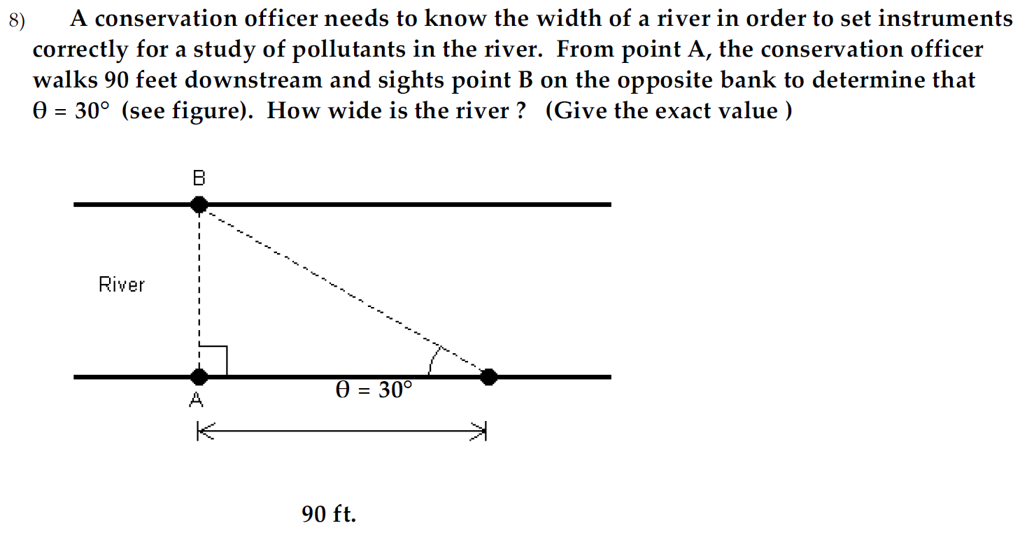
From given triangle, width (AB) of river can be calculated as
$$\tan{{30}^{0}}=\frac{AB}{90}$$
$$→AB=90×\tan{{30}^{0}}=30\sqrt{3}ft.$$
Width of river = $30\sqrt{30} ft.$

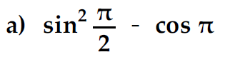
$$→ {\left(\sin{\frac{π}{2}}\right)}^{2}-\cos{π}$$
$$→ 1^{2}-\left(-1\right)→ 1+1=2$$

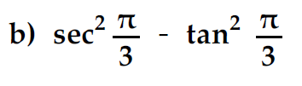
$$→ {\left(\sec{\frac{π}{3}}\right)}^{2}-{\left(\tan{\frac{π}{3}}\right)}^{2}→ {\left(\frac{1}{\cos{\frac{π}{3}}}\right)}^{2}-{\left(\tan{\frac{π}{3}}\right)}^{2}$$
$$→ \frac{1}{{\left(\frac{1}{2}\right)}^{2}}-{\left(\sqrt{3}\right)}^{2}→2^{2}-3 =1$$

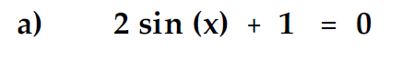
$$2\sin{x}= -1→\sin{x}= -\frac{1}{2}$$
$$\sin{x}is negative i.e. III, or IV quadrant$$
$$→x=\frac{7π}{6},\frac{11π}{6}$$
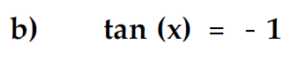

$$\tan{x}= -1$$
$\tan{x}$ is negative i.e. II or IV quadrant
$$→x=\frac{3π}{4} ,\frac{7π}{4}$$

